Date: 8-May-2018

TASK 1

ENTITY RELATIONSHIP MODEL DESIGNING

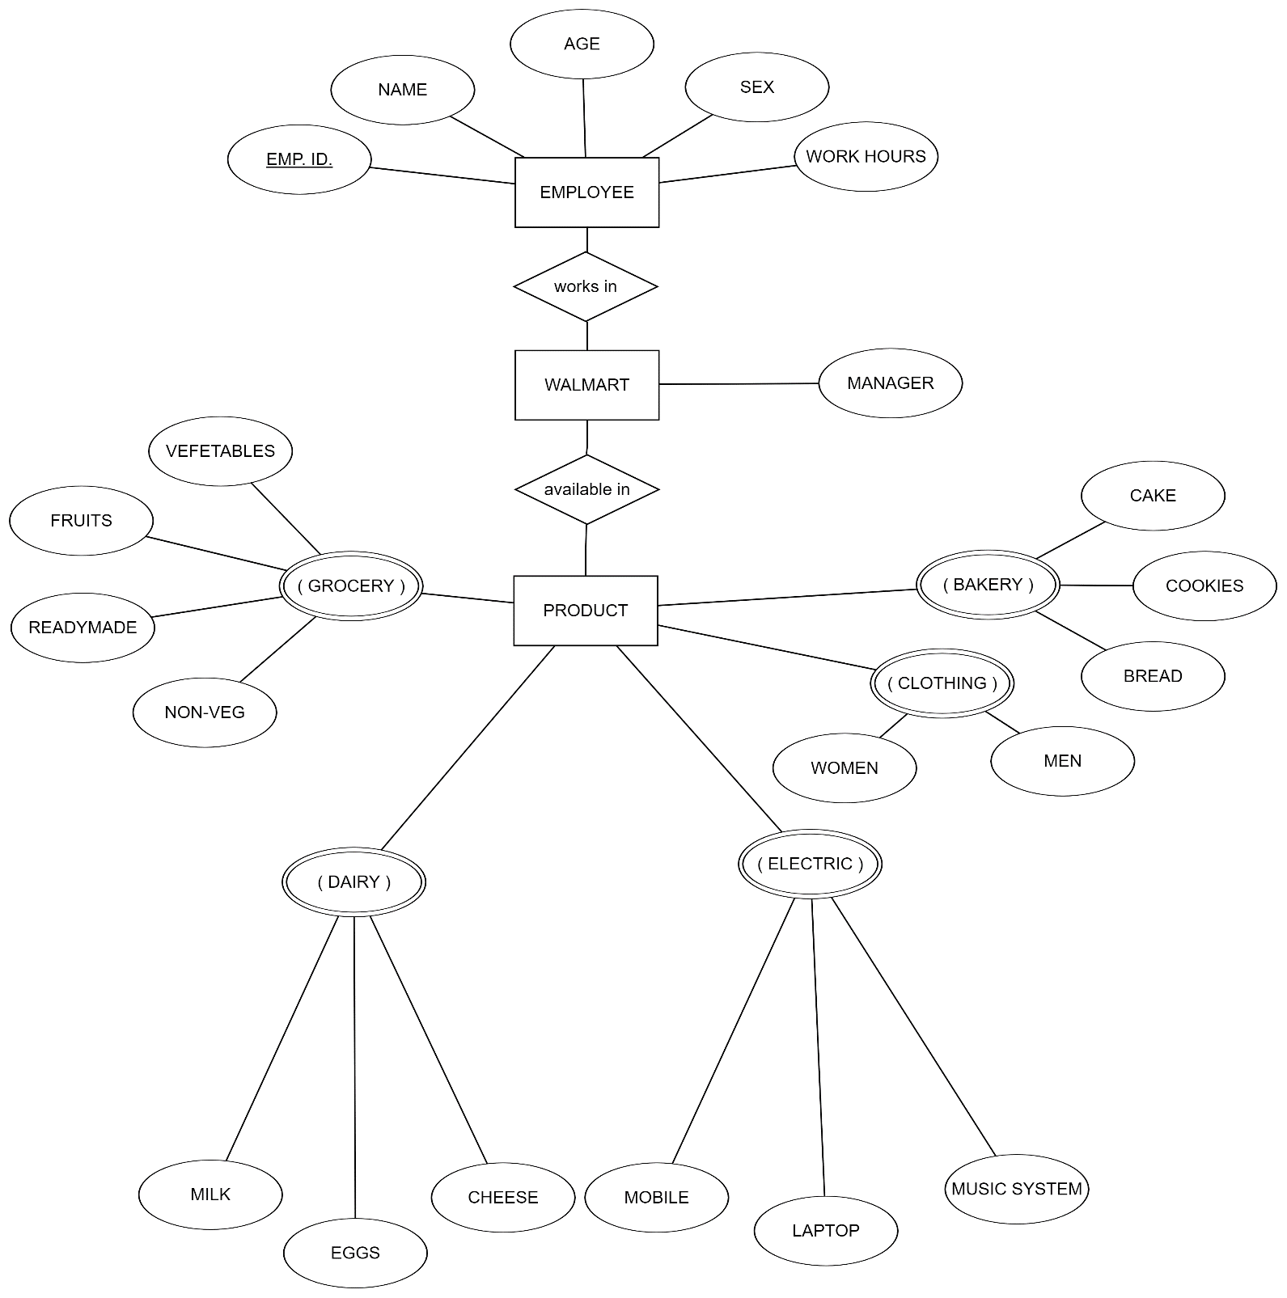

Entities:

* Walmart
* Employee
* Product

Attributes with Entities:

* Walmart
* Manager
* Employee
* Employee Id. (unique)
* Name
* Age
* Sex
* Work hours
* Product
* Bakery (multivalued and composite)

1. Cake
2. Cookies
3. Bread

* Clothing (multivalued and composite)

1. Men
2. Women

* Electric (multivalued and composite)

1. Mobile
2. Laptop
3. Music System

* Dairy (multivalued and composite)

1. Milk
2. Eggs
3. Cheese

* Grocery (multivalued and composite)

1. Vegetables
2. Fruits
3. Readymade
4. Nonveg

* Relationship between Entities:
* Employees work in Walmart
* Products available in Walmart